Use This Template For Design Projects Conducted By Professionals, Industry Practitioners or Students
AUTHOR FAMILY NAME. A^{1*} and AUTHOR FAMILY NAME. B²
¹First Author Department/Division, Then University/ Institute/Company, Then city, Country
Email of first author here
²Second Department/Division, Then University/ Institute/Company, Then city, Country
Email of second author here
(Do not write name/author details: affiliations and contact emails details when submitting the initial submission. But write when submitting the publication-ready final)

Executive Summary — The Executive Summary should be presented as a continuous narrative without subheadings. It should provide a concise overview of the project, introducing its background, context, purpose, process, outcomes, and overall contribution. Authors are encouraged to structure the narrative logically while maintaining a clear flow. Visual material may be included where appropriate to support the project. The opening paragraph of the executive summary should not include a subheading and must provide a clear overview of the project, outlining its background, context, purpose, and significance. The text should be written in formal, professional language suitable for publication, using Barlow 11pt Regular font. The executive summary should range between 1000 and 1,500 words, with a maximum of two images (a third only if essential), each properly captioned and referenced. All citations must follow the APA referencing style, with corresponding entries listed in the Reference section. Including text, images, and references, the complete layout should not exceed four pages. A sample text: Sri Lanka’s Kolam mask tradition is a vivid fusion of sculpture, storytelling, and performance, where each mask communicates character through expressive exaggeration, humor, and stylized form. Although widely documented through cultural and ethnographic studies, few researchers have examined Kolam masks using methods that allow their visual structure to be measured and compared. This study introduces a new approach by adapting the morphometric system developed by Liu, Chen, and Chang (2019), originally created to analyze stylized cartoon characters, to the study of three-dimensional Kolam masks. The adaptation demonstrates how digital measurement and visual analysis can be applied within a heritage context, linking modern design methods with the study and preservation of traditional craft. The research transforms a two-dimensional analytical framework into one suited for three-dimensional cultural artifacts, offering a structured way to identify and compare expressive proportions across four main Kolam traditions: Benthara, Ambalangoda, Mirissa Udupila, and Mirissa South.
The next section should introduce the aim or purpose of the project, supported where appropriate by relevant literature, contextual research, or professional background. This helps readers understand the motivation and significance of the work. This is a sample text: The aim of the study is to explore how Liu, Chen, and Chang’s (2019) morphometric model—originally designed for stylized two-dimensional characters—can be adapted and applied to the study of Sri Lankan Kolam masks as a consistent and repeatable digital method for examining their facial structure and stylistic variation. The study modifies the analytical system so that it can accommodate the three-dimensional characteristics of handcrafted Kolam masks, identifies measurable facial features such as lengths, angles, and areas that reveal artistic exaggeration and regional variation, and establishes a repeatable image-based process for documenting and comparing Kolam masks without physically handling the artifacts.
The following section should briefly explain how the project was developed, including the design process, methods, tools, experimentation, or implementation, as appropriate to the nature of the project. This is a sample text: In Liu et al.’s (2019) original framework, cartoon faces were analyzed through vertical, horizontal, and angular measurements connecting nineteen fixed points around key features such as the eyes, nose, mouth, and chin. This study follows the same geometric logic but adapts it for handcrafted masks, which differ in material form and spatial depth. Because an exact replication of the model was not possible, the framework was simplified to nineteen reference points that could be consistently identified from photographs. Nine main angles and six facial regions—forehead, eyes, nose, mouth, jaw, and overall face—were selected for measurement. All images were scaled to a “human-face frame” derived from the average proportions of twenty Sri Lankan faces, ensuring comparability across different masks. Twelve masks representing three well-known Kolam characters—Adabera Kolam, Mudali Kolam, and Police Kolam—from the four regional traditions were photographed under even frontal lighting and analyzed digitally. The process involved image preparation, marking key facial points, measuring proportional relationships using vector software, and comparing these results to human facial averages to determine levels of exaggeration.
The next section should highlight the key outcomes, findings, insights, or reflections gained through the project, supported by visual material where appropriate. This is a sample text:A case study of an Adabera Kolam mask from Ambalangoda demonstrates the method’s precision. The ratio between eye height and overall face height was 0.32, compared with a normalized human baseline of 0.28, indicating a 14 percent enlargement of the eye region and a deliberate emphasis on expression. Comparative findings revealed that masks from Mirissa South displayed the strongest exaggeration in the eyes and nose, while those from Bentara exhibited more balanced proportions. These results confirm that the adapted system can transform visual impressions of expressiveness into measurable data and reveal stylistic distinctions among regional traditions.
The concluding section should summarise the overall contribution of the project to design, research, education, industry, or society. Authors may also reflect on the broader implications, limitations, or future directions of the work. This is a sample text:The study highlights how digital analysis can serve as a bridge between design research and heritage studies. Translating a two-dimensional model to a three-dimensional context required addressing issues of scale, curvature, and perspective. Using proportional ratios rather than fixed measurements allowed reliable comparison despite differences in mask size. This image-based method enables researchers to study fragile artifacts without direct contact, supporting both preservation and analytical understanding. It demonstrates that digital measurement approaches, when appropriately adjusted, can provide new insights into the visual language of traditional craftsmanship.
The findings offer a clear, repeatable process for examining stylization in folk art and create a foundation for future integration with advanced tools such as 3D scanning and photogrammetry. The method also establishes a practical framework that connects digital design techniques with the study of traditional craftsmanship. However, certain limitations remain: only frontal photographs were analyzed, excluding side profiles and depth variations; the dataset of twelve masks limits statistical generalization; and the manual plotting of reference points introduces minor variation that could be minimized through automation.
By adapting Liu et al.’s (2019) facial-analysis system to Sri Lankan Kolam masks, this study establishes a design-based approach for documenting and interpreting heritage artifacts. The process converts visual interpretation into measurable information and provides a foundation for comparing artistic styles across regional traditions. Beyond its immediate cultural value, the study demonstrates how analytical methods from design can be reinterpreted to preserve and understand vernacular art, reaffirming the enduring creative and cultural significance of Sri Lanka’s Kolam masks.
Include figures where they meaningfully support the project. Authors are encouraged to combine related visuals into composite figures where appropriate.
Keywords: Kolam Mask Tradition; Facial-Analysis System; Cultural Artifacts; Visual Analysis

Figure 1
Liu, Chen, and Chang’s (2019) morphometric model
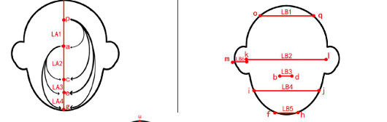
Note. The Original framework by Liu et al. (2019) showing the vertical, horizontal, and angular measurements used to analyze facial structure through nineteen fixed reference points. Nine main angles and six facial regions—forehead, eyes, nose, mouth, jaw, and overall face—were selected for measurement.
https://www.interaction-design.org/literature/topics/ethics-in-design

Figure 2
Four Traditions of Adabera Kolam
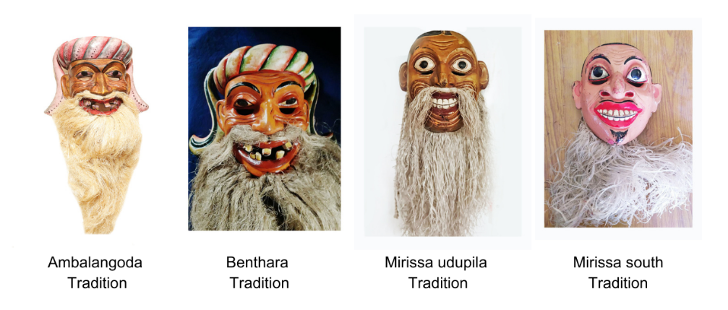
Note. The mask of Andabera (the announcer) represented across the four Kolam mask traditions.

Acknowledgment (Only if Required)
This manuscript is based on the author’s undergraduate dissertation completed under the supervision of xxx xxxxxxxxx at the Department of Integrated Design, University of Moratuwa. The author sincerely thanks her for her guidance, and the custodians and artisans of the Ambalangoda and Bentara Kolam mask traditions for their generous collaboration.

References
Becker, C., de Lema, D., & Tannen, A. (2019). Balancing Business Goals and Ethical Responsibility: The Dilemma of
Digital Designers. Journal of Design Ethics, 7(3), 215-230.
Binns, A. (2018). Exploring Ethics in the Design Process: Lessons from Prototyping and User Testing. Proceedings of
the ACM Designing Interactive Systems Conference, 451-463.
Buchanan, R. (2001). Design and the Culture of Ethics. Design Issues, 17(3), 60-68.
Brown, T. (2009). Change by Design: How Design Thinking Creates New Alternatives for Business and Society. Harper
Business.
Dastin, J. (2018). AI Ethics: The Impact of Algorithmic Decisions on Society. The Ethics of Artificial Intelligence and
Robotics. Stanford University Press.
Interaction Design Foundation (IDF). (n.d.). Ethics in Design: How to Make Ethical Design Decisions.
https://www.interaction-design.org/literature/topics/ethics-in-design

